**AIM :**

Create the database for Database Project assigned, having at least three Relations on WAMP/ LAMP /XAMPP /SQL server.

**PROCEDURE :**

1. Open XAMPP server

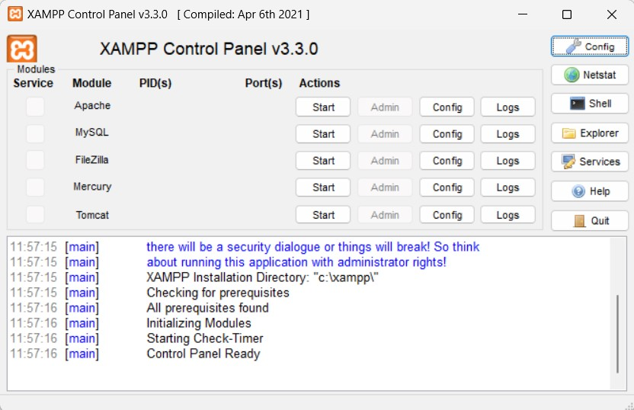

1. Click on “Start” adjacent to Apache and MySQL

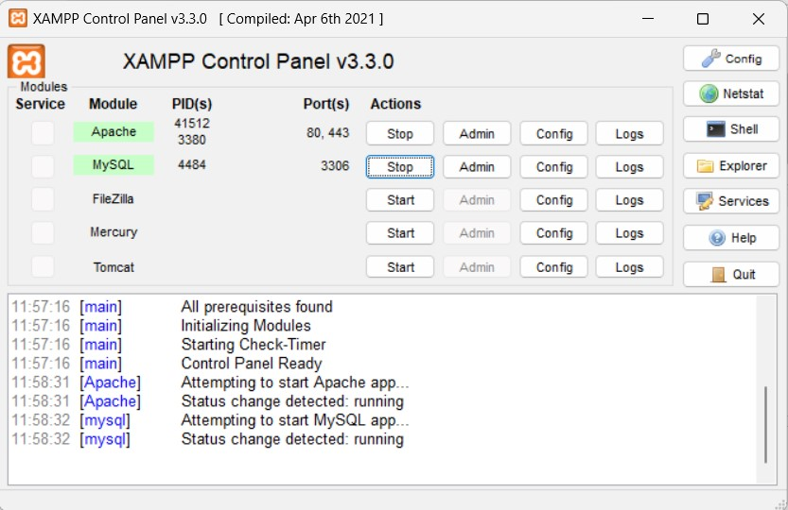

Then click on Admin adjacent to “Apache” or “MySQL”

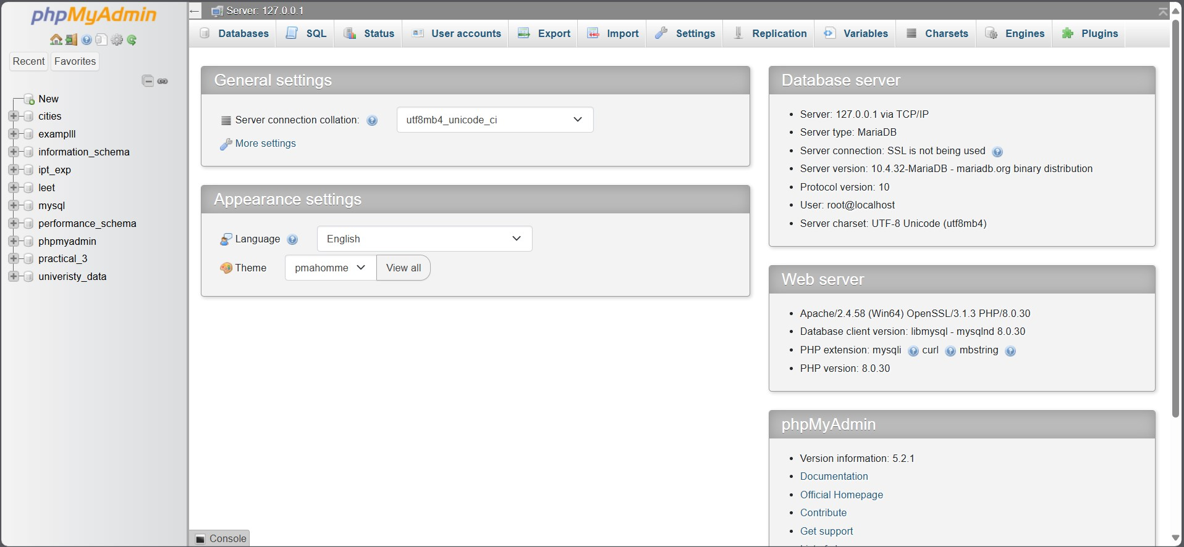

1. Go to the left database manager and click on “New”

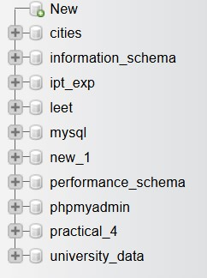

Give the database a name

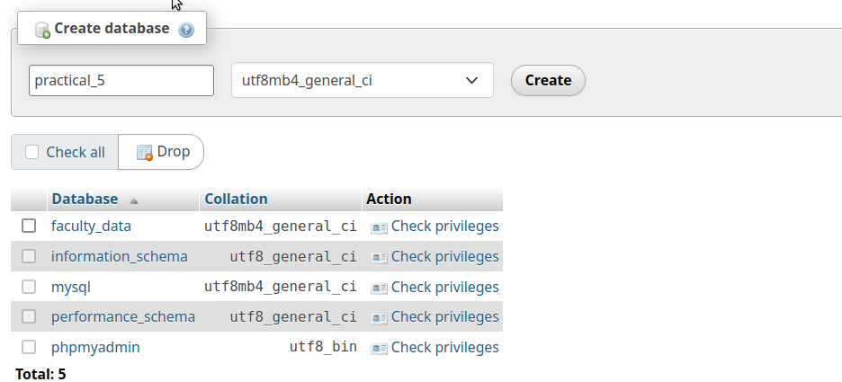

And then click on “Create” button

1. Under the structure tab create a new table and name is “faculty_info” and click on the “Create button

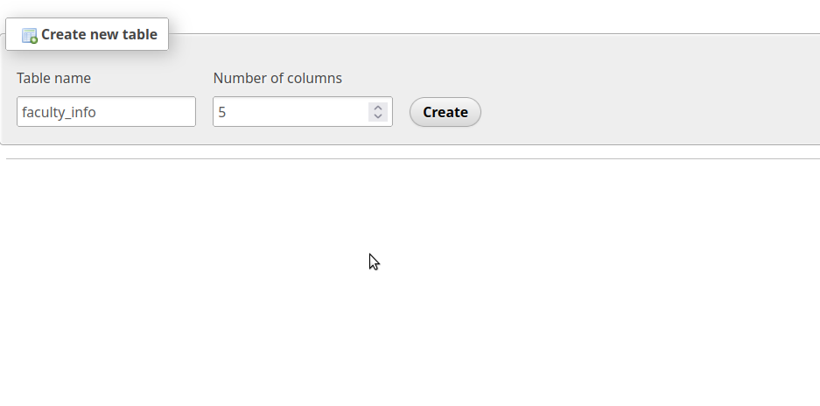

1. You will be prompted to Name the columns that you have created in the table and enter their data type and other details

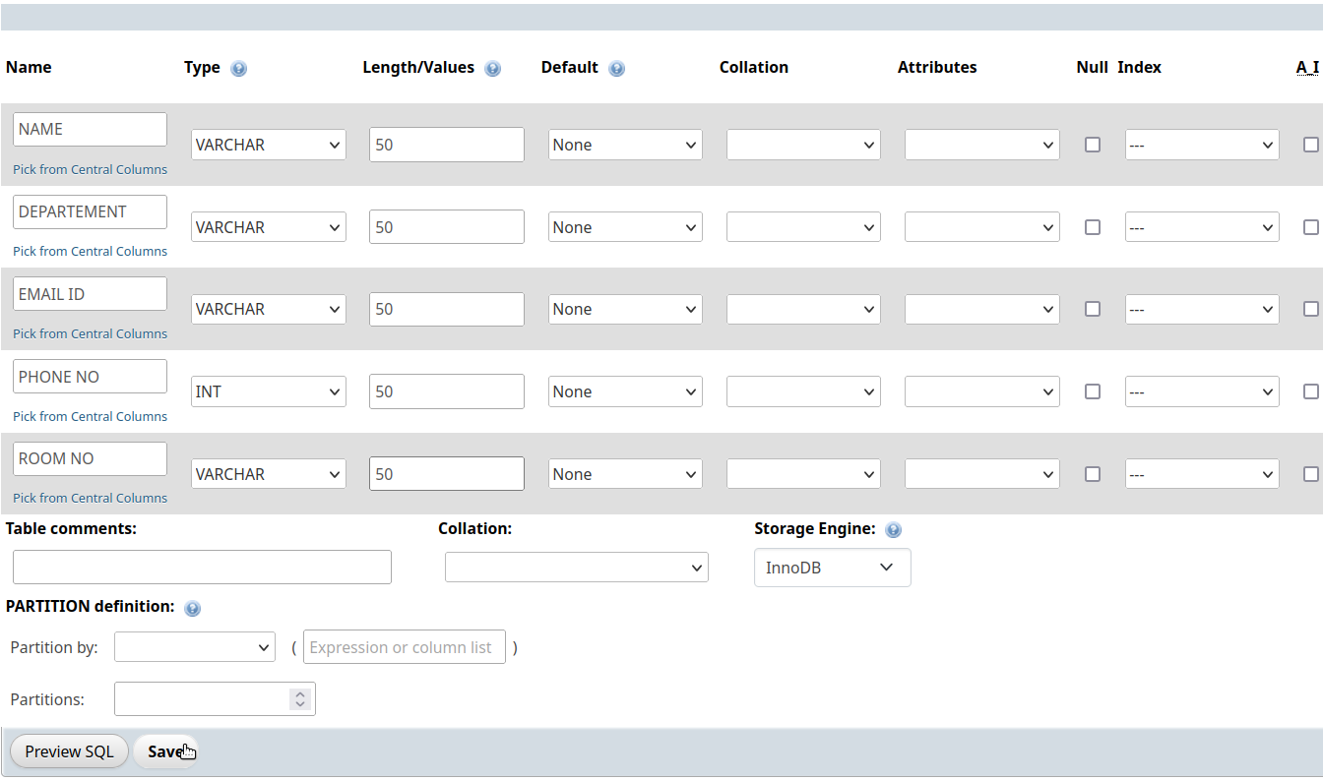

Click on “Save”

1. Go to the SQL tab and enter rows using an SQL query

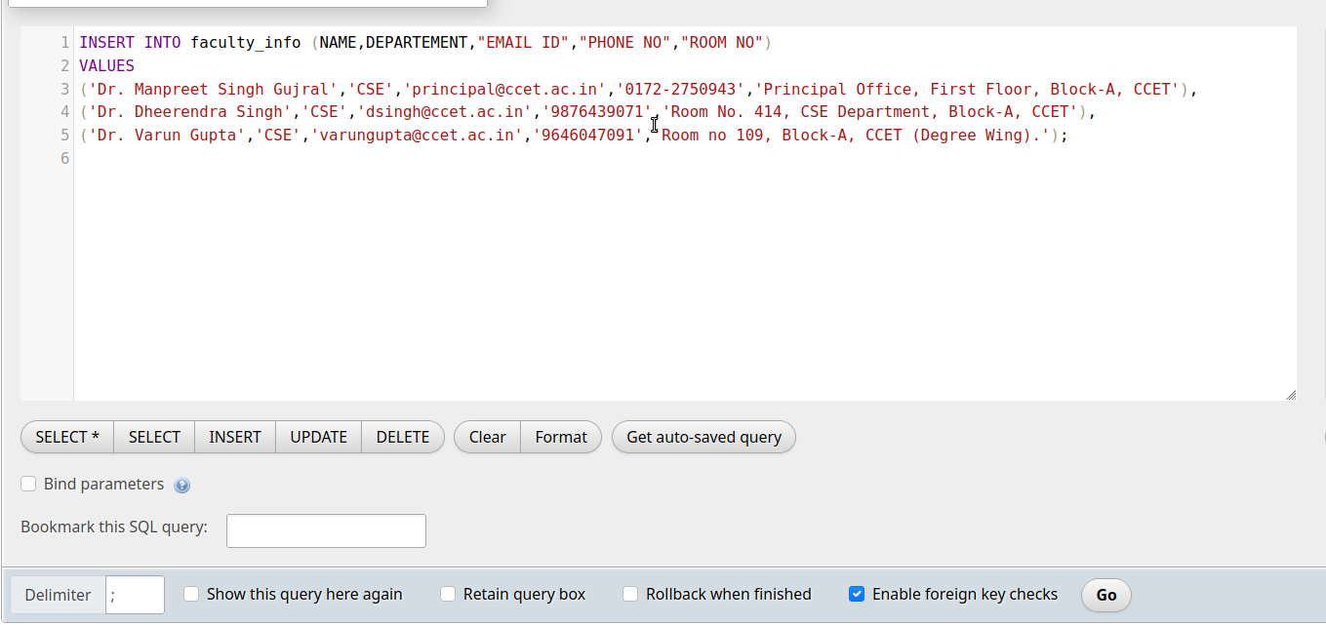

Click on the “Go” button

The confirmation of entry of the three rows will be shown as follows

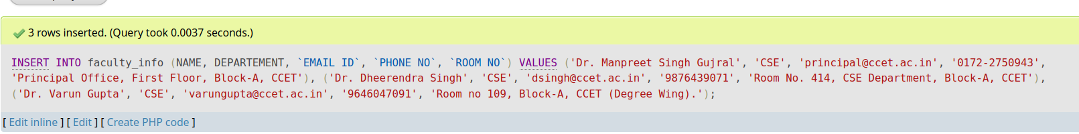

1. Go to the Browse tab to see your table

The rows will be visible in the table



Alternatively you can view the table without going to the view tab by giving the following command in the sql tab.

SELECT * FROM `faculty_info`

And this will display the table in the same format

1. Similarly you can insert the rest of the data

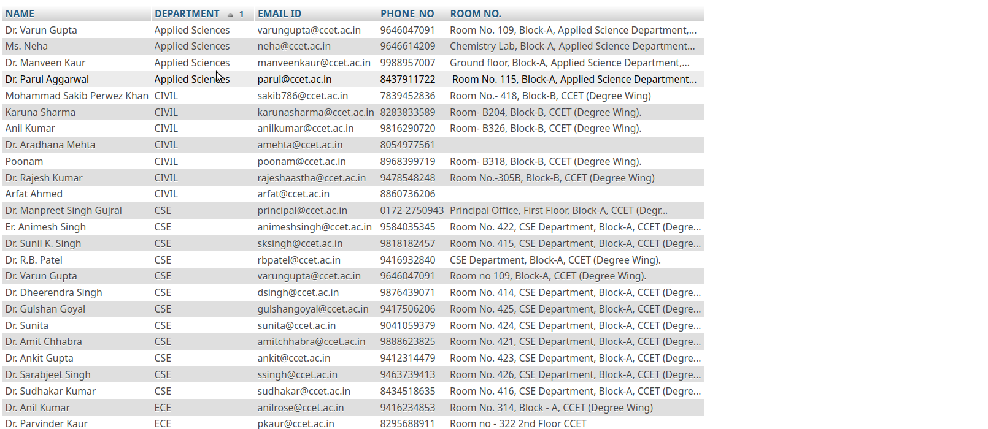

1. Now lets create a second table with sql query rather than xampp interface The query to do so is

CREATE TABLE faculty_data (

NAME VARCHAR(50),

DEPARTEMENT VARCHAR(50), DESIGNATION VARCHAR(50),

QUALIFICATION VARCHAR(50)

);

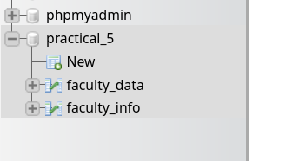

The table will appear in the database as desired

1. You can start inserting the data with the same query as last table

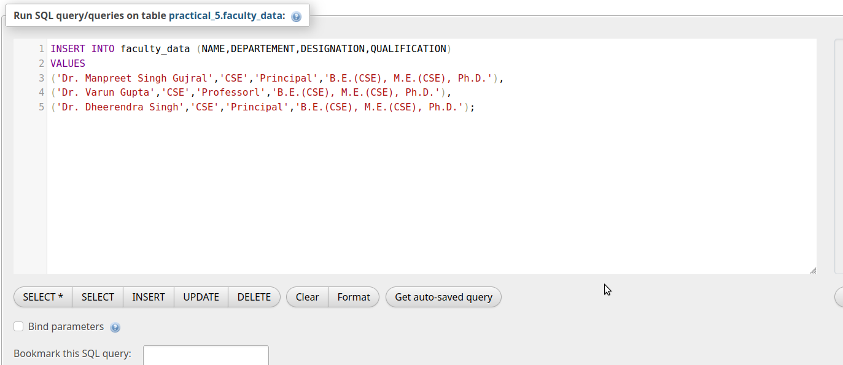

You will be able to see the value



Similarly add the remaining value to the table

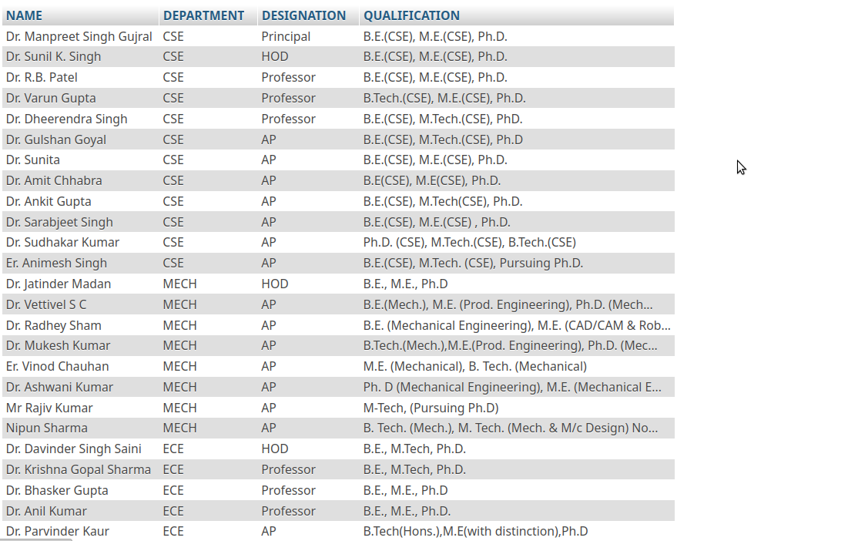

1. Similarly for the third table

